**OFFICIAL COORDINATION REQUEST FOR**

**NON-ROUTINE OPERATIONS AND MAINTENANCE**

**COORDINATION TITLE-** 24JDA22 – LPS Modification Construction Near the North Fish Ladder

**COORDINATION DATE-** 11/27/24

**PROJECT-** John Day Dam

**RESPONSE DATE- 11/12/24**

**Description of the problem –** The John Day Project (JDA) would like to have a contractor repair the north fish ladder (NFL) lamprey passage system (LPS) during the adult passage season.

Installation of 4” HDPE pipe, ball-valves, hoses, etc. will occur within 50-feet of the ladder. Additionally, an estimated 40-70 anchors will need to be affixed to the ladder itself (see figure 1).

This work will not require a ladder outage. However, the Fish Passage Plan states: “Research, non-routine maintenance, fish-related activities, and construction will not be conducted within 100' of any fishway entrance or exit, within 50' of any other part of the adult fishway, or directly in, above, or adjacent to any fishway, unless coordinated with FPOM or FFDRWG by the Project, District Operations and/or Planning or Construction office (*JDA 2.1.1*)”.

The construction window is scheduled to occur between 1 March 2025 and 15 May 2025. The actual work is expected to take approximately 2-weeks. The actual work window will not be known until the contract is awarded. However, the contract cannot be submitted until the ladder-adjacent work is approved to take place. As the contract is yet to be awarded, the actual tool being used for the anchors is unknown. After speaking with several JDA mechanics, I was told the best tool for the job would be a battery operated rotary-hammer. The typical decibel range of a rotary-hammer is about 75-100 decibels (similar range as a vacuum cleaner to a hand dryer/handheld drill).

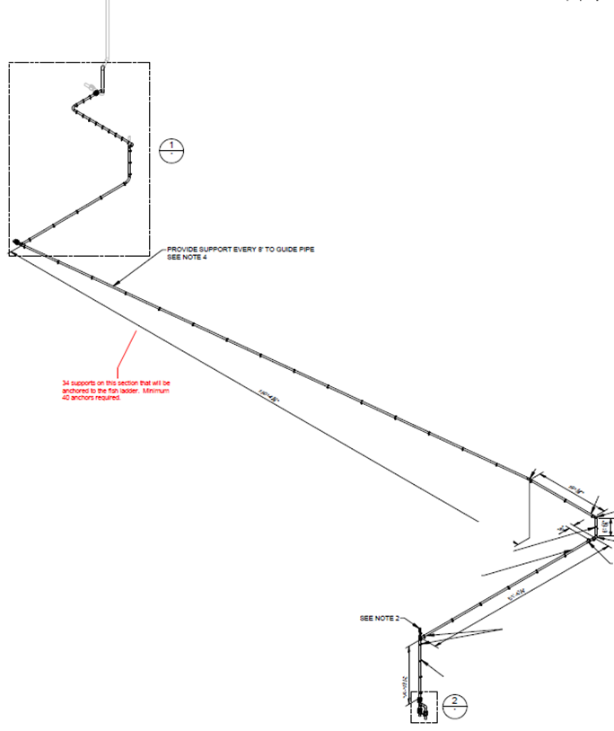

Figure 1: Proposed LPS piping around the NFL. The black bands shown along the length of the pipe are proposed anchor points that will need to be affixed to the ladder.

**Type of outage required –** No outage is necessary.

**Impact on facility operation –** Noise from the construction may affect adult passage.

**Dates of impacts/repairs –** Approximately 2-weeks between 1 March 2025 and 15 May 2025.

**Length of time for repairs** – Approximately 2-weeks

**Analysis of potential impacts to fish-** Noise from the construction may slow fish passage in the ladder.

.

**Summary statement – expected impacts on:**

**Downstream migrants:** There is no expected impact to downstream migrants.

**Upstream migrants (including Bull Trout):** Fish passage in the north fish ladder (NFL) may be slowed due to construction noise. The Chinook and steelhead passage numbers can be seen in figure 2 and figure 3.

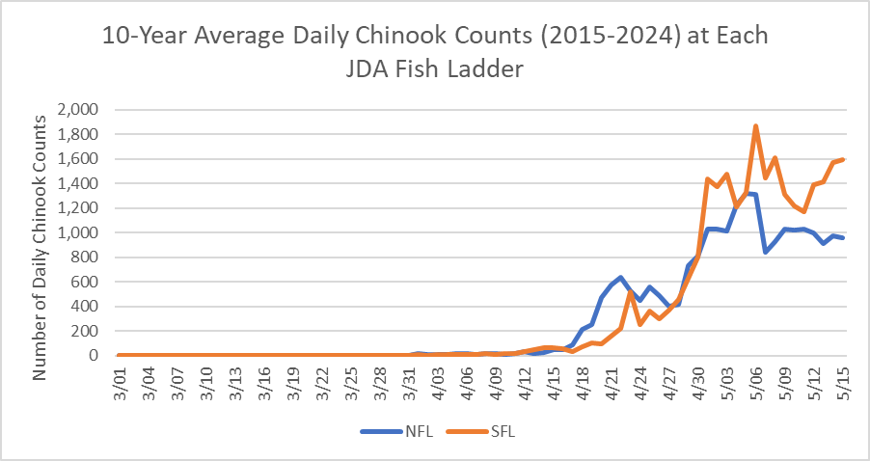

Figure 2: 10-year average (2015 – 2024) daily Chinook counts at JDA for the north and south fish ladders during the proposed construction window.

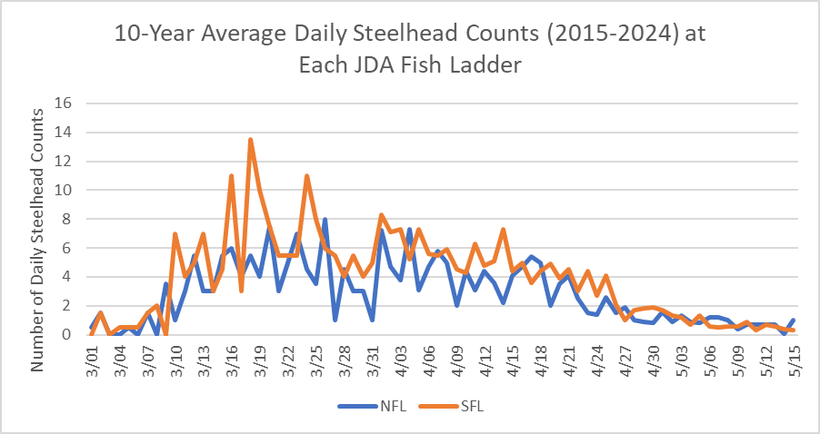

Figure 3: 10-year average (2015 – 2024) daily steelhead counts at JDA for the north and south fish ladders during the proposed construction window.

**Lamprey:** There were 34-lamprey that passed JDA during the proposed construction window in 2024, with a 10-year average (2014 – 2023) of 46-lamprey (see figure 4).

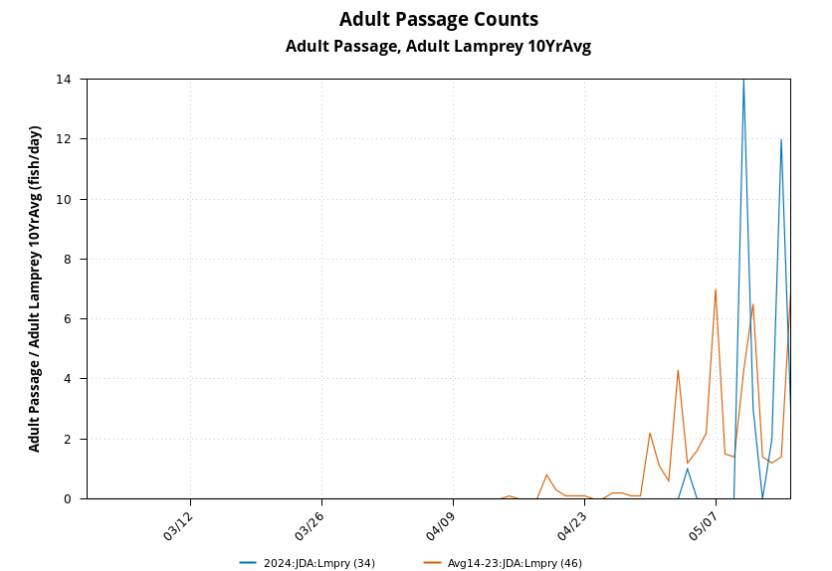

Figure 4: The 2024 lamprey counts for the north and south fish ladder at JDA. There were 34-total lamprey, with a 10-year average (2014 – 2023) of 46-lamprey.

**Comments from agencies**

**Final coordination results**

Please email or call with questions or concerns.

Thank you,

David Miller

Chief of Fisheries

John Day Dam

[David.l.miller@usace.army.mil](mailto:David.l.miller@usace.army.mil)

541-739-1063